SHORT TERM SCIENTIFIC MISSION (STSM) SCIENTIFIC REPORT

This report is submitted for approval by the STSM applicant to the STSM coordinator

Action number: FP1405
STSM title: Active and intelligent fibre-based packaging - innovation and market introduction (ActInPak)
STSM start and end date: 25/07/2018 to 25/10/2018
Grantee name: 1

PURPOSE OF THE STSM:
In this present study, the incorporation of antioxidant, β-carotene, in whey protein concentrate (WPC) capsules using Natural Deep Eutectic Solvents (NADES) as solvent through emulsion electrospraying technique is presented. The encapsulation of the β-carotene in a coating material, which isolate the ingredient from the environment, could help to increase the shelf life of the food product. However, their high hydrophobicity supposes an additional challenge for the food industry. NADES could be a green alternative to be used instead of concentional organic solvents, which make the encapsulation suitable for food applications. The visiting laboratory had responsibility to produce and chacterize these systems in host’s laboratory (Spain), and had responsibility to to conduct couple of characterization studies in visiting’s laboratory (Turkey). After detailed literature survey and achieved good results, it is expected that after this study completed at least 1 original paper will be published.

DESCRIPTION OF WORK CARRIED OUT DURING THE STSMS

Materials
Whey protein concentrate (WPC) was purchased from Davisco Foods (USA) and was used without further purification. The composition per 100 g of product consisted of ~80 g of protein, ~9 g of lactose, and ~8 g of lipids, being the rest water and minerals. Span20 was purchased from Sigma-Aldrich (USA). Distilled water was used throughout the study. Four different Natural Deep Eutectic Solvents (NADES), NADES1 (ChCL:propanediol:water), NADES2 (ChCl:Glucose:water), NADES3 (ChCl:Glycerol), DES4 (ChCl:butanediol), were obtained from University of Montpellier (France). Also, synthetic bioactive, β-carotene, and solutions of β-carotene in four different NADES’ were obtained from University of Montpellier (France).
Preparation of Solutions
WPC solutions were prepared by dissolving a precise amount of the material in distilled water through gentle stirring at room temperature in order to achieve three different concentrations of 20%, 30% and 40% (wt./vol.). This solutions were used to prepare the single WPC capsules. For all of the cases, 5 wt.% of Span20 surfactant was used. In the case of emulsion, initially concentrated solutions of bioactive in four different NADES’ were added to the aqueous WPC solutions separately to attain a final 2%, 10% and 20% (vol./vol.) concentrations. The resultant mixture was then mixed using a vortex mixter TX4 Digital Vortex Mixer from Velp to generate an emulsion.
Characterization of the Solutions
The surface tension of the solutions was measured using the Wilhemy plate method in an EasyDyne K20 tensiometer (Krüss GmbH, Hamburg, Germany). The viscosity of the solutions was measured using Visco Basic Plus from Fungilab. The conductivity measurements were carried out using a HI98192 conductivity probe from Hanna Instruments. The measurements were done at room temperature.
Electrospraying Process
The electrospinning apparatus, equipped with a variable high voltage 0-30 kV power supply, was assembled. The anode was attached to a stainless steel needle connected through a wire to a 5 mL plastic syringe. The syringe containing the solutions was placed horizontally in the cradle of a syringe pump (KD Scientific Inc., Holliston, U.S.A.). The copper ground electrode was connected to a stainless steel plate where the capsules were collected. The distance between the needle and the collector was set at 15 cm. The capsules were obtained using a voltage range of 17-23 kV and a flow rate range of 50 – 100 µL/h.
Scanning Electron Microscopy (SEM)
The morphology of the electrospun mats was examined by scanning electron microscopy (SEM). The SEM micrographs were take using a Hitachi S-4800 electron microscope (Tokyo, Japan) at an accelerating voltage of 10 kV and working distance of 13-14 mm. The samples were previously sputtered with a gold-palladium mixture for 3 minutes under vacuum. The average capsule diameter was determined via ImageJ Launcher software program from the SEM micrographs in their original magnification.
Loading Capacity of whey protein concentrate (WPC) capsules
The loading capacity (LC) of the samples were calculated according to Eq. (1).
$$LC\left(\%\right)=\frac{Mass of bioactive}{Mass of bioactive+Mass of WPC}.100 (1)$$

DESCRIPTION OF THE MAIN RESULTS OBTAINED

The solution parameters of the prepared WPC solutions with and without surfactant (5 wt.% Span20) were given in Table 1 and 2.
Table 1. Solution parameters of WPC solutions without the surfactant.
Solution Parameters | Viscosity  (cP) | Surface Tension (nN/m) | Conductivty  (mS)
20% WPC | 8.51 | 46.4 | 4.958
30% WPC | 62.6 | 47.9 | 4.926
40% WPC | 264.8 | 40.6 | 4.881

Table 2. Solution parameters of WPC solutions with %5 w/w Span20.
Solution Parameters | Viscosity  (cP) | Surface Tension (nN/m) | Conductivty  (mS)
20% WPC | 8.64 | 28.6 | 5.902
30% WPC | 61.8 | 31.1 | 6.055
40% WPC | 266.0 | 29.0 | 6.091

As it can be seen from Table 2, addition of 5 wt.% of Span20 surfactant decreased the surface tension averagely 35% for all of the WPC solutions. Also increased the conductivity 20% averagely. In terms of electrospraying of WPC, the concentration of 20% was found to have low viscosity (8.51 cP). Furthermore, too much dripping was observed on the collector while electrospraying. In order to overcome dripping, the distance was increased to 20 cm and the applied voltage was further increased to 25 kV. However, the droplets were seen not to be dried during the process and excessive of dripping was observed on the collector. For the 40% WPC, the optimization of the electrospraying parameters was found to be difficult due to the its high viscosity (266.0 cP). For this reasons and the ease of optimization of 30% WPC, the concentration of 30% WPC was choosen for the further productions. Additionally in the literature, it was observed that the 30% WPC concentration are the most favorable for the electrospraying processes.

Table 3. Solution parameters of 30% (wt./vol.) WPC solutions with %5 w/w Span20.
Solution Parameters | Viscosity  (cP) | Surface Tension (nN/m) | Conductivty  (mS)
WPC + 10% NADES1 | 91.2 | 28.9 | 21.06
WPC + 10% NADES2 | 97.8 | 33.4 | 20.01
WPC + 10% NADES3 | 99.4 | 30.7 | 20.76
WPC + 10% NADES4 | 95.1 | 33.0 | 19.80
WPC + 2% NADES1 | 101.2 | 31.0 | 6.8
WPC + 2% NADES2 | 98.6 | 32 | 6.6
WPC + 2% NADES3 | 98.3 | 32.8 | 6.4
WPC + 2% NADES4 | 100.9 | 35.1 | 5.92
WPC + 10% NADES3 + β-carotene | 95.4 | 31.3 | 16.04
WPC + 10% NADES4 + β-carotene | 93.0 | 32.6 | 15.66

Table 3 shows that conductivity values of the solutions were increased 212% averagely by the increase of NADES concentration from 2% to 10%. Furthermore, the addition of antioxidant, β-carotene, decreased the conductivity 21.8% averagely.
Loading capacity results are summarized in Table 4. It was calculated that the loading capacities of β-carotene in 2% NADES’ are relatively low (6.67 x 10⁻³ max, 0.0667 x 10⁻³ min) comparing to the previous study by Lagaron et al. (2012) which is the encapsulation of β-carotene with aqueous WPC/glycerol solution system [1]. Besides, loading capacities of WPC/NADES system increased to 3.7 x 10⁻³ for 10% NADES3 and 37 x 10⁻³ for 10% NADES4 by increasing the concentration of NADES to 10%.
Table 4. Loading capacity of β-carotene-loaded WPC capsules.
Bioactive | Loading Capacity (%)
β-carotene (in 2% NADES1) | 1.67 x 10⁻³
β-carotene (in 2% NADES2) | 0.0667 x 10⁻³
β-carotene (in 2% NADES3) | 0.667 x 10⁻³
β-carotene (in 2% NADES4) | 6.67 x 10⁻³
β-carotene (in 10% NADES3) | 3.7 x 10⁻³
β-carotene (in 10% NADES4) | 37 x 10⁻³
β-carotene (in Lagaron et al. [1]) | 79.3 x 10⁻³

Scanning electron microscopy micrographs shown in Fig. 1 demonstrate that spherical WPC capsules are obtained through electrospraying from a 30 wt.% WPC concentration as well as from the emulsion with different NADES’ containing β-carotene. For various samples such as 30% WPC + 2% NADES1 and 30% WPC + 2% NADES1 + β-carotene, it was observed that the humidity may caused the capsules not to dry during the electrospraying process.
Scanning electron microscopy micrographs shown in Fig. 1 demonstrate that spherical WPC capsules are obtained through electrospraying from a 30 wt.% WPC concentration as well as from the emulsion with different NADES’ containing β-carotene. For various samples such as 30% WPC + 2% NADES1 and 30% WPC + 2% NADES1 + β-carotene, it was observed that the humidity may caused the capsules not to dry during the electrospraying process. Additionally, for the higher concentration of NADES3 and NADES4 (10% (v/v)) spherical WPC capsules are obtained as it can be seen in Fig. 1.i and 1.j. The average capsule diameter was measured in the range of 1.5 μm to 3.3 μm.
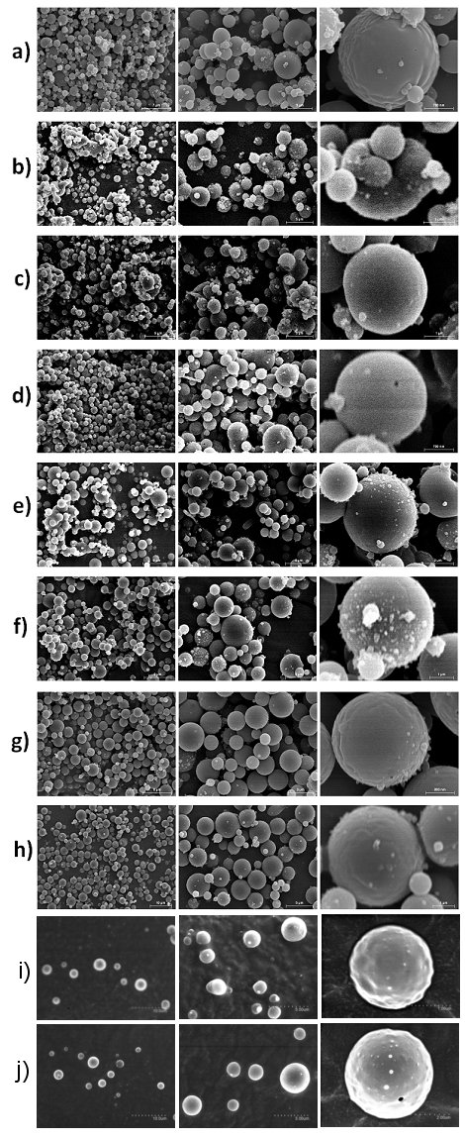

Figure 1. Scanning electron microscopy (SEM) images of: a) 30% WPC, b) 30% WPC + 2% NADES1, c) 30% WPC + 2% NADES1 + β-carotene, d) 30% WPC + 2% NADES2, e) 30% WPC + 2% NADES3, f) 30% WPC + 2% NADES3 + β-carotene, g) 30% WPC + 2% NADES4, h) 30% WPC + 2% NADES4 + β-carotene, i) 30% WPC + 10% NADES3, j) 30% WPC + 10% NADES4 . Scale markers of 10 µm, 5µm and 1 µm for the first, second and third columns of the images, respectively.

[1] A. Lopez-Rubio, J.M. Lagaron, Whey protein capsules obtained through electrospraying for the encapsulation of bioactives, Innovative Food Science and Emerging Technologies 13 (2012) 200-206.

ONGOING STUDIES

Due to the time limitation, the visiting laboratory will continue to do missing characterization in Turkey. The missing characterization is stability tests by UV-vis irradiation. Stability against oxidation of the β-carotene-containing WPC capsules will be evaluated by placing the samples under UV light at a room temperature. After fixed periods of illumination times, the variation in the sample absorbance will be measured using a spectrophotometer as an indicator of β-carotene degradation by oxidation. After detailed literature survey and achieved good results, it is expected that after this study completed at least 1 original paper will be published.

